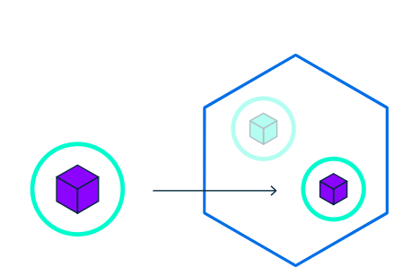

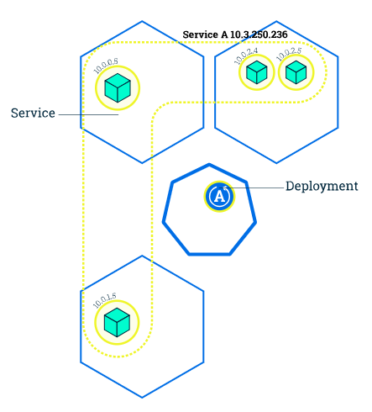

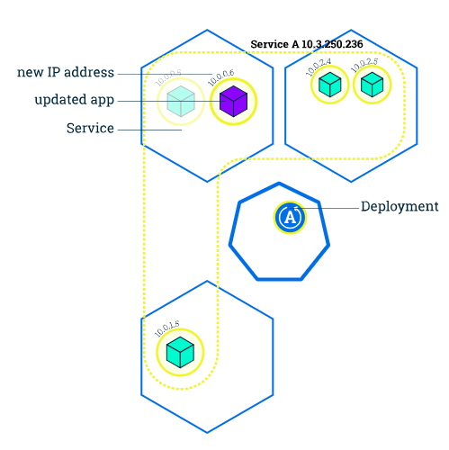

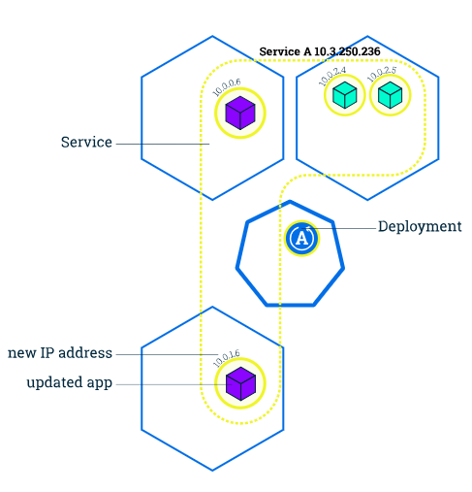

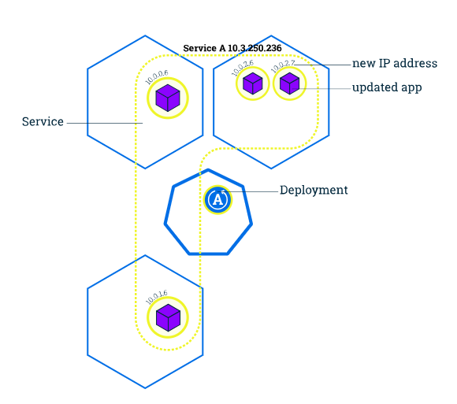

The diagrams are self-explanatory. **Rolling updates**allows Deployments to occur with zero downtime by incrementally updating Pods instances with new ones. The new Pods will be scheduled on Nodes with available resources. Now let’s see how this happens

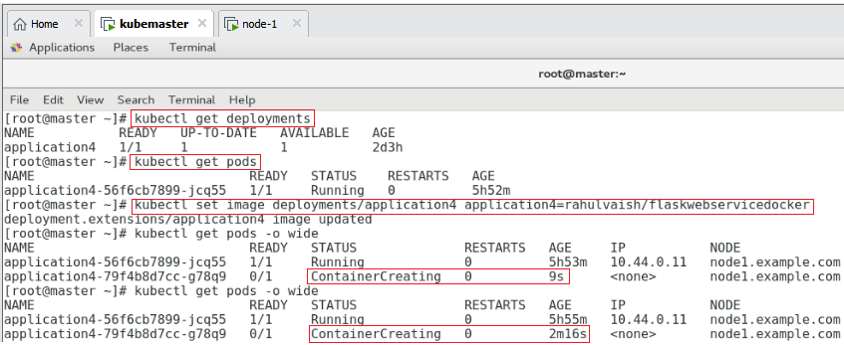

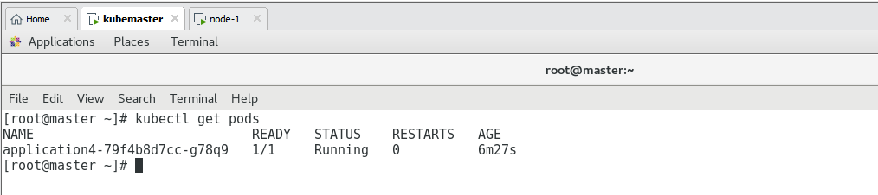

Replacing **springbootdocker** with **flaskwebservicedocker**

Notice the old image was 5 hours 53 minutes old and new one is 6 minutes old ! ☺

So far so good..but what if wrong deployment happened and we need to rollback the same:

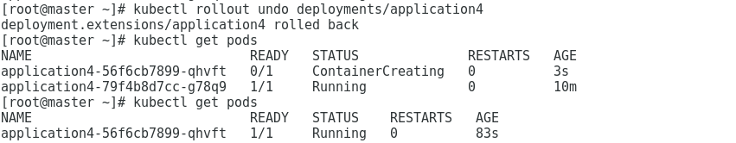

On checking:

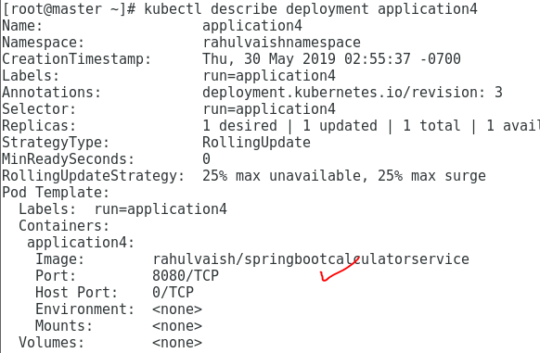

As we can see that, the deployment has been reversed : D